OKEMOS SPECIAL NEEDS

DAY CAMP

Our camp program is designed to foster a supportive and nurturing atmosphere of social interactions among special needs children. Our goal is to promote an environment of tolerance and respect for each other while enjoying a wide variety of activities. Don’t let your child miss this exciting opportunity to experience an awesome summer.

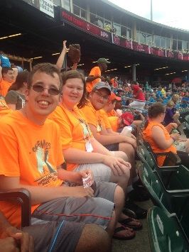

OBJECTIVES
- Weekly themes provide an opportunity to practice reading, writing and creative skills.
- To provide experience in building social skills through peer interaction.
- To build self esteem, confidence, and leadership.
- To provide exposure to the community environment as fully as possible.

FIELD TRIPS
AND

ACTIVITIES

A camp calendar will be sent home the first day of camp.

Campers will enjoy field trips including…

Golfing at Funtyme Adventure Park
Bowling at City Limits
Visiting the MSU Children’s Garden
Going to Potter Park and Binder Park Zoos

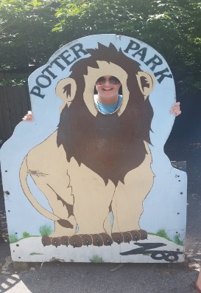

Many fun activities including…

Swimming each week
and
Cooking classes

OKEMOS SPECIAL NEEDS
DAY CAMP
SUMMER 2018

Serving
Special Needs Students
and Their Families
in the Mid-Michigan Area
for Over 30 Years

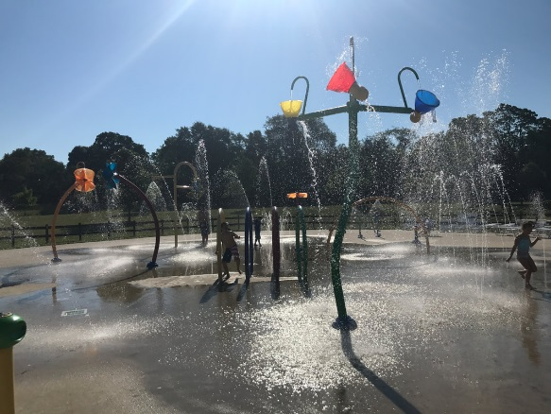

June 18 – August 10, 2018
(No camp July 2-6)

Okemos Community Education
1826 Osage Drive
Okemos, MI 48864
(517) 706-5020

S P E C I A L N E E D S D A Y C A M P I N F O R M A T I O N

COST

4 Weeks - $865

5 Weeks - $1025

6 Weeks - $1221
7 Weeks - $1414

Payment in full due by June 1, 2018

A non-refundable registration fee of $35 is included in the fees above. Make checks payable to Okemos Special Needs Day Camp and mail to the address below.

Special Needs Day Camp
Okemos Community Education
1826 Osage Drive
Okemos, MI 48864

The Okemos Special Needs Day Camp is a self-supporting program using the facilities of Okemos Public Schools. Campers seeking financial assistance are encouraged to contact service clubs such as Kiwanis, Lions, Rotary or Elks, or local agencies like Community Mental Health, Lutheran Social Services, Adoption Subsidy, and Michigan Department of Human Services.

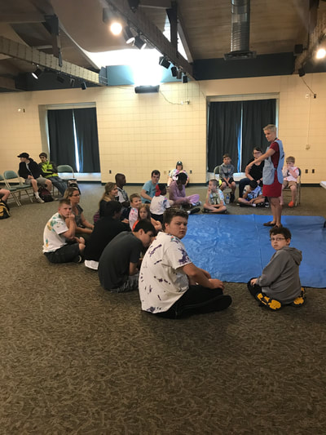

LOCATION

Okemos High School
2800 Jolly Rd., Okemos 48864
Rooms A101, A103, A105

TIME
Monday – Friday
8 a.m. – 2 p.m.*

*It is a parent’s responsibility to make certain that the camper is picked up at the time specified for each day. A late fee will be charged for all late pickups.

STAFF
- Elena Mapley and Jamie DeLong, Camp Directors
- Additional staff includes special education teachers, counselors,
college students, and volunteers.
Staff ratio 1:6.

ELIGIBILITY

Individuals with special needs ages 7 and older are encouraged to attend camp. In order to attend camp trips, campers must demonstrate the ability to stay with the group and follow simple directions.
Individual observations may be used to determine eligibility if necessary. Please call for more information. All camp participants must be toilet-trained and not display aggressive behaviors towards self or others.

QUESTIONS?
Questions about camp, please call Elena Mapley at 706-4831 or Jamie DeLong at 706-5454.
Questions about fees/payments, please call Kelli Guthrie at 706-5021.

